**West High School**

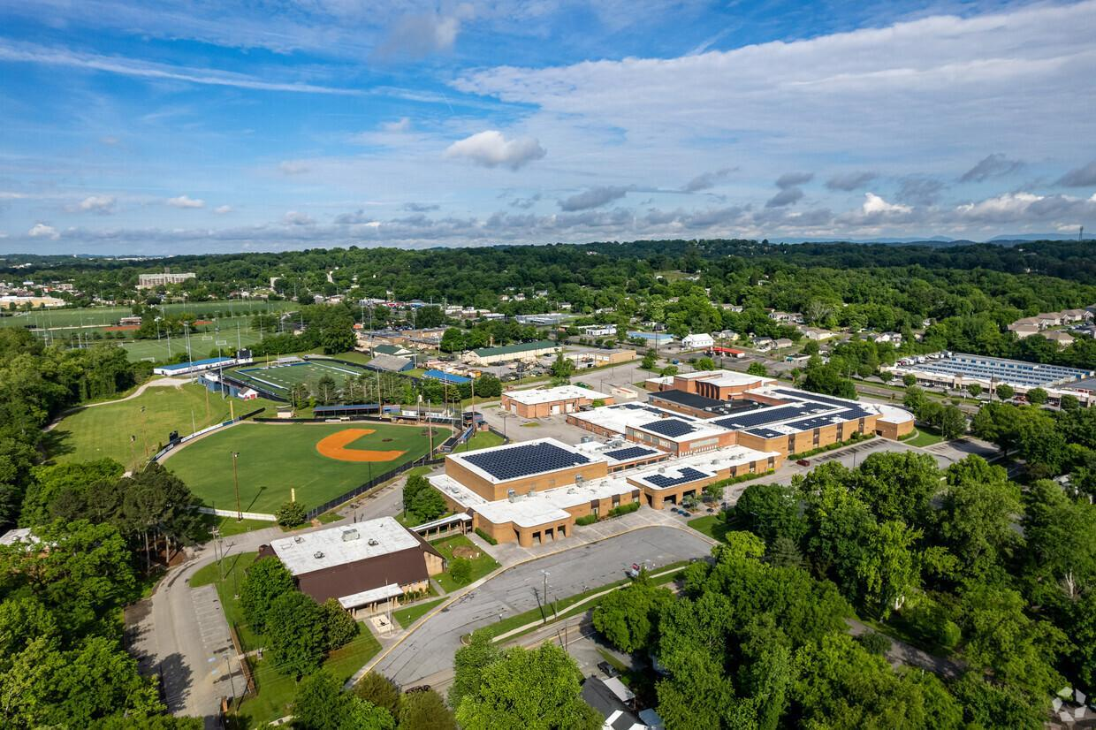

**Student Handbook**

**2024 – 2025**

***DR. ASHLEY SPEAS, PRINCIPAL***

**(865) 594-4477**

[**www.knoxschools.org/wesths**](http://www.knoxschools.org/wesths)

Parents, Students and Community Members,

I have the greatest job ever which is to be the Principal of a culture that promotes excellence for every child at West High School. West High School is dedicated to every student’s success. West has a supportive administrative team that has extremely high expectations for our teachers and students. Our faculty and staff are dedicated to making sure students come first and are determined to continue to mold generations of life-long learners. We have a desire and passion to push our students to the next level academically. We also want to continue to partner with the community to strengthen the opportunities for our students. Our greatest achievements will not be possible without the support of the parents and community we serve. We are who we are because of our school community. We are … **OneWest**.

I look forward to being a part of our team as we push our school to success for 2024-2025!

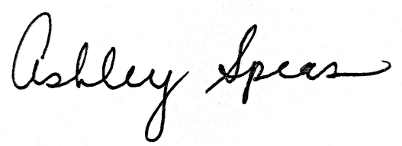

Dr. Ashley Speas

Executive Principal

West High School

**Contents**

Academics

* [Program of Study](https://www.knoxschools.org/cms/lib/TN01917079/Centricity/Domain/3635/WHS%20PROGRAM%20OF%20STUDIES%2022_23.pdf)
* IB Programme
* IB FAQ’s
* 865 Academies

Athletics (fines)

Attendance

* Attendance Policies
* What do do if…
  + you want to leave early
  + you are late to school
  + you want makeup work
  + you are asked to go on a field trip
* Absences for Out of School Suspension
* Driver’s License Requirements (SF1010)

Cafeteria Guidelines

Disciplinary Policies

* Terms and Definitions
* Bullying/Harrassment
* Dress Code
* Bus Conduct
* Cell Phones
* Tardy Policy
* Discipline “Q & A”
* School-Wide Discipline Plan
* Seach and Seizure
* Zero Tolerance

Fees, Dues, Textbooks

Guidelines for Gift/Food Delivery

Library-Media Services

[Map of West](https://drive.google.com/file/d/1XOEBcVmS-BqCM_Hd2wlR1E4fu53SMNP7/view?usp=sharing)

Medication Requirements

Parking and Traffic Information

Personal Conduct

Personal Belongings

Restricted Areas

Schedules

* [Knox County Schools 2024-2025 Calendar](https://www.knoxschools.org/cms/lib/TN01917079/Centricity/Domain/2295/2024-2025.pdf)
* Red/Blue Calendar
* [Bell Schedules](https://docs.google.com/document/d/1QvEUpyCH841mCKWWihjgcrScr5RnekuJe7HIpzhsm9Q/edit)
* [Lunch Schedules](https://docs.google.com/spreadsheets/d/1OG3YH-snG4yUQbZssFpfmx-VGw29V708XZRqhg93lYY/edit#gid=0)
* [West High School Events Calendar](https://docs.google.com/document/d/1FwutFHkL83gDCVfgt36sEi_S_nuntLckEZW7X1bzJxM/edit?usp=sharing)

School Safety

* Safety regulations within the building
* Hallways
* Procedures for drills/emergencies
  + Fire
  + Storms/ “Shelter-in-Place”
  + Building Evacuation
  + Lockdown/Intruder

School Structure

* Administration
* Grade-Level Information

Student Services (Counseling)

* Student Services Staff
* Grading Scale
* AP and IB 5 Point Policy
* Grading Period Dates
* Grade Reporting
* End of Course Exams

Technology

Title IX

**ADMINISTRATIVE STAFF**

**Executive Principal:**

**Ashley Speas**

**Assistant Principals:**

**Nate Martin FRAC Academy 9th Grade**

**Kim Maples WISE Academy 10th Grade**

**Kelly Forester Upper House 11th Grade**

**Chris Caruthers Upper House 12th Grade**

**Athletic Director:**

**Paul Romero**

**Coaches and Coordinators:**

**Gina Hodges–Academy Coach**

**Hannah Johnson–Instructional Coach/ IB MYP Coordinator**

**Shari Valencic–IB DP/CP Coordinator**

**STRUCTURE**

**9th GRADE ACADEMY**

**FRAC Principal: Nate Martin**

**Dean: Nat Scott**

**Counselor: Lisa Roberts**

The West High School Freshman Academy (FRAC) is an academic community and program for all first-time 9th graders at West High School. The faculty within FRAC consists of core subject teachers, a dean, a 9th grade guidance counselor, and a freshman assistant principal. This core support team will ensure that the class of 2027 is successful and that students are given the chance to reach their full potential throughout their first year of high school.

The introduction of a freshman academy at West High aims to assist 9th graders in meeting and exceeding expectations concerning student attendance, discipline, and learning goals. The teachers and support staff of the academy will diligently foster positive relationships as well as develop appropriate levels of rigor in the classrooms. Students will be encouraged and supported in making wise social and academic decisions through extensive self-awareness opportunities. The freshman counselor will counsel students on their career goals and interests and provide detailed information on college readiness, college alternatives, and financial aid.

The West High School 9th Grade FRAC is designed to help our students start high school “strong” and finish high school even stronger. Welcome to a wonderful and rewarding academic community, Class of 2028!

**10th GRADE ACADEMY**

**WISE Principal: Kim Maples**

**Dean: Sarah Green**

**Counselor: Anna Brownlee**

The WISE Academy (West’s Institute for Sophomore Education) is an academic community that is designed to continue the academic success of the FRAC. There is a nucleus of core subject teachers, a dean, a counselor, and an administrator. The core nucleus will continue the mission of ensuring that each student maintains their academic success while preparing them for their Junior and Senior years.

**11th GRADE ACADEMY**

**UPPER HOUSE Principal: Kelly Forester**

**Dean: Dani Sorrells**

**Counselor: Kelly Page**

**12th GRADE ACADEMY**

**UPPER HOUSE Principal: Chris Caruthers**

**Deans: Shannon Suddath**

**Counselor: Tabitha Rawlings**

The UPPER HOUSE Academy is an academic community of the junior and senior classes that are designed to continue the academic success of the WISE Academy. There is also a nucleus of core subject teachers, a dean(s), a counselor and an administrator that makes up each of the junior and senior classes of the Upper House. The core nucleus will continue the mission of ensuring that each student maintains their academic success while preparing them for their Junior and Senior years. The core nucleus mission for both groups is to ensure that each student maintains their academic success while preparing them for a future in a post graduate school and/or their place in the world as a successful and contributing member of society.

**STUDENT SERVICES (SCHOOL COUNSELING)**

The West High School Student Services Department offers a comprehensive program of services and informational resources to students, parents, community, and staff. A major emphasis is placed on the individual student and his/her needs. School Counselors are certified/licensed educators trained in school counseling with unique qualifications and skills to address *all* students’ academic, personal/social and career development needs. The counselor assignments are:

**Department Chairs: Sarah Bast and Kelly Page**

**9th Grade Academy: Lisa Roberts 10th Grade Academy: Anna Brownlee**

**11th Grade Upper House: Kelly Page 12th Grade Upper House: Tabitha Rawlings**

**College Counselor: Sarah Bast Career Mentor: Amelia Baker**

The services provided through the Student Services Department include the following: individual counseling, small and large group guidance, freshman orientation, new student orientation, scheduling, assistance with post-secondary education, career development, college information (scholarships, financial aid, vocational programs, colleges, application processes) and testing. The counselors work as a team in cooperation with faculty, administration, support staff, parents and community volunteers to provide these services. Information on testing schedules, college and career fairs, scholarship availability, financial aid and employment opportunities is provided to the student body on a regular basis by way of announcements and memos.

**GRADING SCALE AND GRADE REPORTING**

Grade Descriptors % Scale Grade Points*

A Excellent 90-100 4

B Good 89-80 3

C Average 79-70 2

D Below Average 69-60 1

F No Credit 59-0 0

*Grade points for Advanced Placement and International Baccalaureate courses receive additional weights as follows: A:5, B:4, C:3, D:1, F:0. Grade points for Honors courses: A:4.5, B:3.5, C:2.5, D:1.5, F:0.

**AP AND IB 5 POINT POLICY**

TDOE is requiring students in AP and IB courses to take the corresponding exam in order to receive the 5 additional points added to their final grade. Students who do not take the AP or IB exam will not receive any additional points. The exception is that all students in  a two year IB course that does not have required IB assessments during the first year will receive five points added to their final grade at the end of year one. Students in a two year course (for example, IB English) who have required IB assessments during the first year must complete these assessments in order to receive the additional five points at the end of the year.

**GRADING PERIOD DATES**

| Grading Period | End Date | Grading Period | End Date |
| --- | --- | --- | --- |
| 4 ½ Weeks | September 9 | 4 ½ Weeks | February 5 |
| 9 Weeks | October 4 | 9 Weeks | March 10 |
| 13 ½ Weeks | November 13 | 13 ½ Weeks | April 21 |
| 18 Weeks | December 20 | 18 Weeks | May 22 |

**GRADE REPORTING**

All classes’ grades are cumulative, representing all class work from beginning of the course to the date of the report. Each successive report is not the average of previous grade reports; rather, it represents the compiled scores of all daily lessons. Grades will be published every 4 ½ weeks and can be viewed on Aspen. If you need a printed copy, please go to Student Services.

**END-OF-COURSE TESTS**

Examination dates for the entire school year are published well in advance so that families may plan accordingly to avoid conflicts on examination testing dates***. Our staff will not be asked by the administration to give examinations early except in very exceptional situations.***

Mandatory state level exams are administered in Algebra I, Algebra II, Geometry, English I, English II, Biology I and US History. KCS policy states that the end-of course (EOC) exam counts for 15% of the final course grade. After EOCs, at the end of the year, full credit will then be awarded for courses taken. Seniors who have a minimum of an “75” average may opt out of the class’s final exam (this exam cannot be a state, IB, or AP exam).

**LIBRARY/MEDIA SERVICES**

**Nancy Williams, Librarian**

**Kate Hoppenrath, Librarian**

**Purpose:** To foster an appreciation of reading andto develop research skills and habits conducive to lifelong learning.

**WHS website**: **knoxschools.org/domain/1442**

How do I access the databases and e-books? Links, usernames and passwords are on the website.

**Hours:** Open 8:05 am - 4:00pm, Monday-Friday

**Fee List:** Overdue books – $0.10/day (maximum fine is $8.00 per item)

Lost book – replacement cost + $5.00 processing fee

**Printing:** There are costs for some kinds of printing, especially graphics and color. Be sure to check with one of the library staff so that you know your cost before you hit “Print”!

**FEES, DUES AND TEXTBOOKS**

**TEXTBOOKS**: Textbooks are assigned to students for most classes. In a few, rare cases it is necessary to use “class sets” of books. All textbooks issued to students must be returned/replaced at the end of the term to the teacher who assigned the book. If the textbook is not returned in good, used condition the cost of replacement becomes the student’s responsibility.

**FEES**: To provide adequate supplies for specified scholastic offerings, it is necessary to request a fee to offset costs for supplies, materials, etc. These class fees are available to pay online and are listed based on the students schedule for the school year.

**DUES**: Some clubs will charge dues for participation and the amount may vary per club. Information for payment will be given by the club sponsor.

**ATTENDANCE POLICIES**

According to School Board policy, maximum effort is made in all classrooms to provide a quality learning experience each day; therefore, time out of a class represents a loss of valuable learning. Knox County’s policies for attendance are designed to encourage students to take personal responsibility for their class attendance and tardies, to provide an opportunity for students to make up work missed and to eliminate excessive absences from their attendance record.

Teachers will take attendance on campus at a designated time each day. Traditional and virtual schools will notify the parents/caregivers of students’ absences. If a student is absent for two or more days, the school will do a well-being check with the student and family.

Students with 5 unexcused absences from school will receive a letter from Juvenile Court warning of potential court action. At 10 unexcused absences, student and parent will be required to attend a Juvenile Court hearing. These absences are cumulative for the entire school year and relate to school absences only, not individual class absences. Excused absences for the following reasons do not count toward those reported to Juvenile Court. **Documentation must be submitted within 5 days of absence(s).**

Excused absence examples:

* Personal illness
* Illness in family temporarily requiring help from the child
* Death in family
* Recognized religious holidays regularly observed by persons of the student’s faith
* Verifiable family emergency
* For students with a parent/guardian who is deployed as a member of the US Armed Forces, excused shall apply provided the student furnishes appropriate documentation of the service member’s deployment. An excused absence for one day when the member is deployed, an excused absence when the service member returns from deployment and an excused absence for up to 10 days for visitation when the member is granted rest and relaxation leave and is stationed out of the country.

All students are expected to attend classes as scheduled, regardless of their status related to absences or grades. (Students must go to class even if they are failing the course.) Failure to attend classes for the above reasons will result in possible consequences for truancy and/or class cuts. **DROPPING OR ADDING CLASSES IS NOT AN OPTION.**

Parent/guardian will be notified when a student is absent.

**TECHNOLOGY**

For our educators and staff, Hāpara offers invaluable resources. It provides them with the ability to view students’ open Chrome browser tabs, allowing for guidance and feedback to empower our students as positive digital citizens. Through the Teacher Dashboard, teachers can easily track learners’ progress across various Google applications, enabling prompt and effective formative feedback that propels our students forward in their academic journeys.

In order to ensure the effectiveness of this system and to maintain a conducive learning environment, I would like to highlight a few important points for students:

* **Use of Student Google Account**s: During school hours, students are required to use their designated KCS student Google accounts, regardless of the device they are using, though we do encourage the use of school chromebooks.

*Please note: If a student is going to use their own personal computer, he/she still must use their KCS google account, google chrome web browser, and the school's WiFi while on school property and for school assignments.

* **School WiFi Usage**: To access online resources, students must utilize the school’s WiFi network.
* **Adherence to Technology Policies**: Intentional use of alternative devices during school hours may result in minor referrals for inappropriate technology use, as outlined in our media agreement.
* **Purpose of Monitoring**: The monitoring of student activity is solely aimed at enhancing academic progress and fostering a secure digital learning space for all.

This implementation is in line with the media agreement previously signed for student Chromebooks, ensuring that our students are equipped with the tools and resources they need while maintaining a safe and conducive learning environment.

**WHAT TO DO IF…?**

**…you want to leave school early…**

When leaving early is necessary, it is essential that parents make a **written request** for early dismissal.

* **With a Note –** Students who need to be dismissed early from school must bring a note signed by a parent. The note should include telephone numbers for parent verification by the office. Notes for early dismissal should be brought to the Front Office by 8:30 am. Students will then pick up their early dismissal slip up back from the Front Office after 1st block.
* **Without a Note** – A parent/guardian must come into the Front Office to check out any student who does not bring a note. In emergency cases, other adults sent by a parent to check a student out of school **must** be included in the student’s ASPEN emergency information. **STUDENT DISMISSAL BY PHONE OR FAX IS NOT AN OPTION! Note**: The Front Office should be notified of any special circumstances regarding access to a student.
* Students who check out during the school day may not return to school that day without an official doctor’s note, court note or parent/guardian sign-in.
* Students arriving on campus (walking, driving, bus) prior to 8:30 am may not leave campus without permission. Doing so will result in disciplinary action.
* **No early dismissals after 3:00 p.m.**

**…you are late to school…**

A student arriving any time after 8:30 a.m. should report directly to the Front Office to receive an Admit Slip. (**Reminder:** arriving during the first 15 minutes of a class is considered tardy; arrival after the first 15 minutes is an absence.) **Note:** Students on campus, but not in class or in the Front Office, are considered cutting class and doing so will result in disciplinary action.

**…you miss class work and want to make it up…**

It is up to the student to initiate the make-up work immediately upon returning to school. Failure to request make-up work within three (3) days of returning to school may result in the lost opportunity for credit for the missed work. It is understood that all requested work must be completed and turned in within 3 days of receiving the assignment or by teacher arrangement. Any missing work will have a negative impact on the student's grade; the representation of the missing grade in Aspen will be under individual teacher discretion. In cases of prolonged illness, teachers will set a reasonable time limit for completion of the work (See KCS Board Policy J-120 for complete district attendance policy).

If students are absent for at least three (3) days, parents may call/email the Student Services secretary, Dana Redd (dana.redd@knoxschools.org), to request make-up work. Student Services and teachers must have 24 hours to gather necessary assignments.

**…you are asked to go on a school sponsored field trip…**

Students who participate in school-sponsored field trips are required to turn in a notarized Knox County Medical Release Form. One form will cover all field trips for the entire year. A notary public is on-site in Student Services to notarize the forms for parents. If the student is under the age of 18, the parent must sign the form in the presence of the notary public.

Students who are TRUANT may be subject to progressive truancy intervention including by not limited to court intervention.

Students may sometimes be absent from the regular classroom for required class activities (i.e. Band concerts, special tests, etc.) or for activities at which students represent the school.

**ABSENCES FOR OUT OF SCHOOL SUSPENSION**

Students who are out of school for disciplinary suspension must follow the policy and procedures for requesting missed work. Suspension days DO count as school/class absences. A student is not permitted to participate in extracurricular activities on any Knox County Schools property if suspended on the day of the activity. OSS is an excused absence.

**DRIVER’S LICENSE REQUIREMENTS (SF1010)**

Tennessee State Law (Title 49, Ch. 6, Tennessee Code Annotated) contains requirements for compulsory school attendance. Another law (Ch. 819 of Public Acts of 1990) sets the requirements for driving privileges for children under the age of 18, tying these requirements to the compulsory school attendance law. This law states that a student will be denied a license or lose an issued license if the student has any of the following:

* Ten (10) or more consecutive unexcused days absent in a term.
* Fifteen (15) or more total unexcused days absent in a term.
* More than half of his/her subjects failed in a term.

For purposes of state guidelines, unexcused absences are those without a doctor’s note, court appearance, or death of an immediate family member. If a license is denied or canceled, a student must do the following to regain driving privileges:

* Attend school thirty (30) days in a row without an unexcused absence and/or
* Pass half or more of his/her classes the next term with D or better.

**To apply for a drivers’ license**, a student must submit a completed **Compulsory School Attendance Form (SF1010)** to the Drivers’ License Bureau. This form is available online or in the school office. The top portion must be completed by the student or parent and then returned to the school secretary for attendance/grade verification and completion of the form. **Note: Two school days should be allowed for completion of this form by the school.**

**PARKING AND TRAFFIC INFORMATION**

West High School strives to provide a safe and secure campus for its students and for all vehicles on its property. Because of the limited parking spaces available, campus parking permits will be sold to eligible twelfth grade drivers (with a valid license) first, and then to eligible eleventh graders on a space available basis. All student drivers are expected to adhere to specific parking/traffic guidelines and to sign a contract agreeing to do so. Violations of these guidelines will be taken very seriously since the safe and efficient operation of the school may be affected. Possible consequences could be, but are not limited to: Booting ($20 removal fee), towing and/or loss of parking privileges.

**Bus drop-off/pick-up is on the Tobler side of the school directly in front of the Gym and should not be used for car riders.**

WHS does not endorse student parking anywhere but on the West campus. Most businesses/organizations near the school do not wish to have students park on their property and may have cars towed at the owner’s expense. Students are encouraged to ride the bus, carpool, or make other arrangements, rather than park in an area that may pose a dangerous situation for students or their vehicles. Parking a vehicle on school grounds entitles the principal or designee to search that vehicle upon reasonable suspicion that school policy or Knox County law has been violated. WHS is not financially responsible for vehicular damage or theft that may occur while the vehicle is on campus. However, campus security can complete an accident report that the student can submit to the student’s automobile insurer. The administration will administer appropriate disciplinary action if vehicle damage is the result of campus safety or rule violations. **NOTE: Parking is a privilege and may be revoked for disciplinary reasons or for vehicle violations. .**

Students will be assigned a parking decal when the parking pass is purchased, and must place stick it on the driver’s side windshield in the bottom corner. Students park anywhere in the white numbered parking spots (yellow numbered spots are reserved for Staff/Visitors). Violators will be booted and fined. (Updated 8/6/2021)

**MEDICATION**

No medication of any kind shall be self-administered by students at school (even with the assistance from school nurses or other school personnel), except when medication must be given on a long-term basis and is necessary to be given during school hours in order for the student to remain in school. Over the counter (OTC) medications are included in these regulations. Any student who is required to take medications must comply with the following regulations:

* The school system has the final decision-making authority with respect to the administration of medications and to reject requests for administering medications.
* Written orders must be provided by a medical health care provider who has the legal right to write a prescription. The order must include the name of the drug, dosage, frequency or time interval, route or method of administration, possible side effects and method of storage.
* One medication per form is allowed on the Physician Forms, and the forms must be renewed each school year.
* A parent/guardian signature is required on the Physician Form for Administration of Self-Medication before a student can be assisted with self-medication.
* All medications, whether prescription or over-the-counter, must be brought to the school by a responsible adult. Students may not carry medications of any kind on their person with the exception of asthma inhalers, Epi-pens, or insulin delivery systems with the written permission from a parent and authorized by a medical care provider.
* All medication must be in appropriate containers which are properly labeled by a medical care provider or pharmacy. An OTC medication prescribed for a student must be provided in its original, unopened, unexpired container with the original label and have the student’s name written on the container.
* Upon receiving medication at school, the quantity of medication received must be confirmed and documented.
* All medications self-administered must be documented.
* School Nurses will monitor the administration, documentation, and storage of all medications.
* The parent/guardian is responsible for picking up an unused medication at the end of the treatment or of the school year.

**Failure to follow the medication policy may result in a student having a disciplinary hearing for a Zero Tolerance offense.**

**See KCS Board Policy “**[**J-352 Medication**](https://www.knoxschools.org/cms/lib/TN01917079/Centricity/domain/974/board%20policies/J-352%20Medication.pdf)**.”**

**GUIDELINES FOR STUDENT MESSAGES, PACKAGES, FLOWERS, BALLOONS, ETC. AND FOOD DELIVERY**

To avoid excessive announcements, interruptions and the overloading of front office personnel, only emergency messages or packages (such as forgotten lunches, lunch money, etc.) from parents/guardians will be accepted for distribution to students during school hours. *Students will be called to the office between classes only*. **NO commercial balloons, flowers, gifts, etc. are to be brought or delivered to students on campus during school hours.**

Due to loss of instructional time, food deliveries from DoorDash, Grubhub, UberEats, and other concierge services will not be permitted. Students who attempt to place and receive orders will not be able to accept them, and appropriate disciplinary action will be taken. The school is not financially liable for any funds lost/wasted if students attempt to order food for delivery.

**PERSONAL BELONGINGS**

Students should consider not bringing expensive cell phones, headsets/earbuds, large amounts of money or any other personal belongings to school due to the risk of loss or theft.

***Subsequently, the school cannot be responsible for such personal items that may be lost or stolen while at school. The school will not be responsible for the recovery of items stolen during the school year.***

**CAFETERIA GUIDELINES AND RULES FOR FOOD AND DRINK**

* Visitors are not permitted in the cafeteria during lunch periods without administrative approval.
* Student seating is allowed only in the cafeteria or the front lobby porch. Students should not wander the school during this time, or they will be subject to out of area or class-cut disciplinary consequences. Special permission may be granted to a teacher to allow an alternative lunch setting through administrative approval. Students must have a pass.
* Each student is to use his/her personal cafeteria number only - **this number is not to be used by any other student, with or without the permission of the owner.**
* Students must present all food and drink items to a cashier for payment. **Food or drink not presented and paid for will be considered stolen**, and appropriate disciplinary actions will be assigned.
* All school behavior guidelines should be followed during lunch.
* **Students must remain in the cafeteria or in designated outside areas during lunch periods. Students should not be in instructional or unsupervised areas.**
* No food and drink (except water) is permitted in classrooms or other instructional areas except by special permission.
* All food and drinks must be consumed in DESIGNATED AREAS only unless by special permission.
* Eating areas are to be left clean and trash-free and trays properly returned to designated area.

**RESTRICTED AREAS**

Students are not allowed in the following areas:

* Parking lots/vehicles during school hours arriving or leaving unless with administrative permission
* Rooms/areas designed for “Staff Only”
* Any unsupervised area during classes without permission
* Instructional Areas during lunch periods
* In the building or on campus after 4:00 pm without staff supervision for a school activity
* In the building before the designated time in the morning without staff supervision

**DISCIPLINARY TERMS AND DEFINITIONS**

**CLASS CUT:** A class cut occurs when a student on campus and does not attend class. This can occur when a student does not show up to a scheduled class OR when a student misses an extended period of class time with a hall pass.

**UNAUTHORIZED AREA:** Being present in areas of the school without authorization. This will often be but always not be determined by the color of the hall pass that the student is carrying.

**CONFISCATION:** Items that are prohibited on school grounds or are a distraction will be labeled as to ownership and turned over to the assigned office. These items may be returned to the student or parents at the Administrator’s discretion. **Note**: Beepers, cell phones, etc. may be turned over to Knox County Security.

**HAZING:** Name-calling, inflammatory or disrespectful remarks, harassment (verbal or physical) is prohibited at all times and is subject to disciplinary consequences.

**MINORS/INFRACTIONS:** a minor offense such as tardy, minor misuse of cell phone, correctable dress code offense, minor horseplay, small class disturbance, etc. These offenses are reported to the PBIS system directly by teachers. After accruing so many of these, a referral is submitted. Infractions are classified as Level 1, 2, or 3 depending on severity and/or frequency.

**REFERRAL**: a referral is handled by an administrator. If a behavior rises to the level past an infraction, in the judgment of the teacher, a referral is submitted and an administrative action will be taken. Some actions, such as class cut, off campus without permission, threats, bullying, harassment, fighting, possession of illegal or prohibited substances, etc, will result in immediate referral and immediate disciplinary action.

**RESTORATIVE LEARNING CENTER (RLC):** RLC is a consequence sometimes given for inappropriate behavior. This consequence involves placement of the student in a special class for at least one-half day with a designated staff member. Students are expected to complete regular academic assignments, participate in some form of school service and follow the schedule and guidelines outlined by the staff member in charge. The student should spend time considering necessary steps to restore with the help of the facilitator to normal scholastic setting, and attempts should be made by the student to correct the behavior in the future.

**ALTERNATIVE TO SUSPENSION (ATS):** For some disciplinary infractions resulting in suspension for 10 or fewer days, ATS may be assigned. ATS is housed in the James Agee building. Students will spend the day with a designated staff member. Students will be expected to complete regular academic assignments, follow the schedule and expectations of ATS, particpate in some form of school service, and reflect through restorative practice. ATS will be considered a form of suspension as outlined in the Knox County Schools Misbehaviors and Disciplinary Options ( Board Policy J-191).

**OUT OF SCHOOL SUSPENSION (OSS):** This is a consequence given for persistent misbehaviors of such a serious nature as to warrant being prohibited from school attendance. Students who receive OSS are subject to the following rules:

* The student is not allowed on any Knox County School campus at any time.
* The student is not allowed to attend any school function, including, but not limited to athletic events, dances, and school performances.

**LONG TERM SUSPENSION:** Any OSS that is longer than four consecutive days is considered “long term.” A disciplinary hearing (DH) will be held before any long-term suspension has been given.

**INITIAL HEARING/DISCIPLINARY HEARING (DH)**: When information is received by administration indicating that a student has committed a violation that could result in a suspension of more than four days, meetings will be scheduled for the following purposes in the order given below:

**Hearing Notification** (Includes Administrator and Student + Parent/Guardian)

* To present information concerning the violation
* To hear the student’s statement or statements of others who may have information relative to the violation

**IEP Team Meeting/504 Team Meeting**

* To determine if violation is a manifestation of the Special Ed or 504 eligbility
* To determine if placement/programming is needed

**Disciplinary Hearing (DH)** (All regular Ed. & Special Ed./504: If not a manifestation)

* To determine guilt or innocence
* To determine the appropriate consequences for the violation

**See KCS Board Policy “**[**J-191 Misbevhaviors and Disciplinary Options**](https://www.knoxschools.org/cms/lib/TN01917079/Centricity/domain/974/board%20policies/J-191%20Misbehaviors%20and%20Disciplinary%20Options.pdf)**”**

**SEARCH AND SEIZURE**

According to Knox County Board Policy Handbook (JCAB), school lockers, backpacks, pocketbooks, etc., as well as vehicles parked on school grounds are subject to search. (Guidelines concerning such searches are outlined in the Knox County Policy Handbook.)

**See KCS Board Policy** [**"J-200 Interrogations and Searches"**](https://www.knoxschools.org/cms/lib/TN01917079/Centricity/domain/974/board%20policies/J-200%20Interrogations%20and%20Searches.pdf)

**ZERO TOLERANCE POLICY**

In order to ensure a safe and secure learning environment free of drugs, violence and dangerous weapons, any student who engages in the following behaviors shall be removed from the base school for a period of not less than one (1) calendar year and shall be offered an alternative placement to complete school work. The Director of Schools has the authority to modify this suspension requirement on a case-by-case basis. Zero tolerance acts are as follows:

Any student who while at a school bus stop, on a school bus, on school property or while attending any school event or activity:

1. Unlawfully possesses a legend drug or any other controlled substance;
2. Knowingly possesses a firearm as defined in 18 U.S.C. § 9212;
3. Commits aggravated assaul and batteryt on a teacher, a School Resource Officer (SRO), an officer of the law assigned to patrol a Knox County School property or other employee of the school system;
4. Possession of explosive or incendiary devices.

It is the School Board's intent that the Director of Schools exercises his/her power to modify to ensure that no student shall be out of school for more than two semesters for a zero tolerance offense. Upon re-entry to the base school, a restorative conference shall be utilized to the extent practicable. The Director of Schools shall consider each zero tolerance case for placement in the alternative school program.

Students should note that possession, use, or distribution of any Delta 8, Delta 9, or CBD products while on campus constitute a violation of the zero tolerance policy and will be subject to the same zero-tolerance disciplinary action.

**See KCS Board Policy “**[**J-194 Zero Tolerance Offenses**](https://www.knoxschools.org/cms/lib/TN01917079/Centricity/domain/974/board%20policies/J-194%20Zero%20Tolerance%20Offenses.pdf)**” at the back of handbook**

**HARASSMENT, INTIMIDATION, AND BULLYING**

Knox County Schools prohibits acts of harassment, intimidation, bullying, and cyber-bullying. A safe and courteous environment in school is necessary for students to learn and achieve. Harassment, intimidation or bullying, like other disruptive or violent behaviors, is conduct that disrupts both a student’s ability to learn and a school’s ability to educate students in a safe and orderly environment; and since students learn by example, administrators, faculty, staff and volunteers should be positive role models in demonstrating appropriate behavior, treating others with civility and respect, and refusing to tolerate harassment, intimidation or bullying. All Knox County Schools teachers and administrative personnel are responsible for ensuring this policy is faithfully implemented in all areas under their purview or direct supervision.

“Cyber-bullying” means bullying undertaken through the use of electronic devices; “Electronic devices” include, but are not limited to, telephones, cellular phones or other wireless telecommunication devices, personal digital assistants (PDAs), computers, electronic mail, instant messaging, text messaging, social media, and web sites.

“Harassment, intimidation, or bullying” means any act that substantially interferes with a student’s educational benefits, opportunities or performance.

If the act takes place on school grounds, at any school-sponsored activity/event, on school-provided equipment or transportation or at any official school bus stop, the act has the effect of:

* Physically harming a student(s) or damaging a student’s property.
* Knowingly placing a student(s) in reasonable fear of physical harm to the student(s) or damage to the student’s property.
* Causing emotional distress to a student(s).
* Creating a hostile educational environment.

If the act takes place off school property or outside of a school-sponsored activity, it is directed specifically at a student or students and has the effect of creating a hostile educational environment or otherwise creating a substantial disruption to the education environment or learning process.

**Students who feel they are being harassed, bullied or intimidated may report this concern to any teacher or school administrator or the office of the Superintendent using any means of communication with which they feel comfortable. Students may report anonymously, and anonymous reports will be treated with the same level of urgency as all other reports.**

Consequences and appropriate remedial action for students who commit acts of harassment, intimidation, or bullying may range from behavioral interventions up to and including suspension or expulsion. The appropriate action will be consistent with established Board policy, case law, and federal and state statutes. Most events classified as any of these categories is reported to law enforcement.

It is important to understand that a harassment, bullying, or cyberbullying event that involves another Knox County Schools student often becomes a school disciplinary issue regardless of the time or location of the action or whether or not the action occurred on school campus. Such actions may become punishable by school officials or may be subjected to law enforcement.

**See KCS Board Policy “**[**J-211 Harassment, Intimidation and Bullying or Cyber-Bullying**](https://www.knoxschools.org/cms/lib/TN01917079/Centricity/domain/974/board%20policies/J-211%20Harassment%20Intimidation%20and%20Bullying%20or%20Cyber-Bullying.pdf)**”**

**STUDENT DRESS CODE**

The following expectations for student dress have been established to promote a safe and optimum learning environment. Apparel or appearance, which tends to draw attention to an individual rather than to a learning situation, must be avoided. In matters of opinion, the judgment of the principal/designee shall prevail.

The following standards will be observed in all Knox County Middle and High Schools:

* Pants must be worn at the waist. No sagging allowed.
* Shirts, blouses, and dresses must completely cover the abdomen, back, shoulders and must have sleeves. Shirts or tops must cover the waistband of pants, shorts, or skirts with no midriff visible. Low-cut blouses, shirts, or tops or extremely tight tops, tube tops, or any top that exposes cleavage are prohibited.
* Head apparel, except for religious or medical purposes, must not be worn inside the school building.
* Footwear is required and must be safe and appropriate for indoor and outdoor activity.
* Clothing and accessories such as backpacks, patches, jewelry, and notebooks must not display:

(1) Racial or ethnic slurs/symbols,

(2) Gang affiliations,

(3) Disruptive, vulgar, or sexually suggestive language or images; nor, should they promote products which students may not legally buy; such as alcohol, tobacco, and illegal drugs.

* Skirts, dresses, and shorts must be beyond mid-thigh length.
* Sleepwear, pajamas, and/or blankets cannot be worn in school.

**Prohibited items include:**

* Large, long, and/or heavy chains
* Studded or chained accessories
* Sunglasses, except for health purposes
* Sleepwear
* Skin-tight outer materials without appropriate coverage.

The school administration reserves the right to determine whether the student's attire is within the limits of decency and modesty. Administration should strive for consistency so the dress code is applied even-handedly to male and female students.

The principal may allow exceptions in special circumstances or occasions such as holidays or special performances and may further prescribe dress in certain classes such as physical education, vocational classes and science labs.

Any student not attired in accordance with this policy shall be subject to correction of the violation. If a correction cannot be made, the student shall be subject to additional disciplinary measures as described in [Policy J-191 “Misbehaviors and Disciplinary Options.”](https://www.knoxschools.org/cms/lib/TN01917079/Centricity/domain/974/board%20policies/J-191%20Misbehaviors%20and%20Disciplinary%20Options.pdf)  This may include sending the student home until the issue can be corrected.

This policy does not preclude individual schools from implementing standardized dress policies with permission from the Director of Schools and the Board of Education after extensive consultation with parents, teachers, and students. Any deviation from the system-wide policy must be submitted in writing to the middle and high school directors for review and recommendation to the Director of Schools and the Board of Education.

**See KCS Board Policy** [**“J-260 Dress Code”**](https://www.knoxschools.org/cms/lib/TN01917079/Centricity/domain/974/board%20policies/J-260%20Dress%20Code.pdf)

**PERSONAL COMMUNICATION DEVICES AND/OR ELECTRONIC DEVICES**

Personal Communication Devices (PCD) and personal electronic devices including, but not limited to, cell phones, camera, recorder, bluetooth devices, iPods, MP3 players, netbooks, laptop or notebook computers or iPads may be stored in backpacks, purses, or personal carryalls. However, the use of the devices during class-time is forbidden unless approved for an academic activity by the principal or the principal’s designee.The guidelines for such use will be at the teacher's discretion, and failure to follow guidelines will result in appropriate disciplinary action. This is not intended to discourage the use of these devices for instructional purposes, but to establish parameters and appropriate oversight for their use. Improper use or storage of PCDs and electronic devices may result in confiscation of the device until it can be released directly to a student’s parents and/or guardians. A student in violation of this policy is subject to related disciplinary action.

Students may possess PCDs while on school property. The devices may be used before and after school, during lunch, and between classes. At all other times the PCD must be in the off mode. The principal or the principal’s designee may grant a student permission to use a PCD during class time for a specific academic purpose or at other times for other purposes that the principal deems appropriate.

A PCD used outside these parameters may result in confiscation of the PCD until it can be released directly to the student's parent or guardian. A teacher may withhold a PCD from a student during a class if the PCD is a distraction to the class or student. **Please note that this paragraph represents a change in policy as of the 2022-2023 school year.**

**Students are prohibited from taking unauthorized photographs or making unauthorized recordings of others at school, on school transportation or at school sponsored events.** Students who record or post videos of other students, such as a fighting video, could be charged on the school level with harassment and will be subjected to school disciplinary measures.

**WARNING:** The taking, disseminating, transferring, or sharing of obscene, pornographic, lewd, or otherwise illegal images or photographs, whether by electronic data transfer or otherwise (commonly called texting, sexting, emailing, etc.) may constitute a CRIME under state and or/federal law. Any person taking, disseminating, transferring, or sharing obscene, pornographic, lewd, or otherwise illegal images or photographs will be reported to law enforcement and/or other appropriate state or federal agencies, which may result in arrest, criminal prosecution, and LIFETIME inclusion on sexual offender registries.

**See KCS Board Policy “**[**J-240 Use of Personal Communication Devices in School**](https://www.knoxschools.org/cms/lib/TN01917079/Centricity/domain/974/board%20policies/J-240%20Use%20of%20Personal%20Communication%20Devices%20in%20School.pdf)**”**

## TARDY CONSEQUENCES

* Students are expected to be on time to school and class. Students who are tardy will be subject to progressive discipline.
* Tardies to school are separate from tardies to class. If a student is not in first period by the time the tardy bell rings at 8:30, students must report to the front office to pick up a pass and report immediately to class. Not doing so will result in a class cut.
* Grade level deans will check tardies weekly: If a student has more than 3 tardies to class* in a week, the following consequences will take place:
  + 1st incident: Dean Conference
  + 2nd incident: Dean Parent Phone Call
  + 3rd incident: Admin conference and loss of food truck privileges.
  + 4th incident: Aspen discipline referral and potential student contract.

*If a student has more than 3 tardies to school in a week, the advisory teacher should refer the student to the grade level social worker to ascertain if there are issues in getting school.

* There will be pre-planned tardy sweeps throughout the school year. These will be sent to teachers by email invite.
  + 1st incident: Block of RLC to be served immediately
  + 2nd incident: ½ Day of RLC to be served immediately
  + 3rd incident: 1 Day RLC
  + 4th + : 1 Day RLC

**TRANSFER OPTION FOR STUDENT VICTIMIZED BY A VIOLENT CRIME AT SCHOOL**

Under the Tennessee State Board of Education’s Unsafe School Choice Policy, any public school student who is the victim of a violent crime as defined under the Tennessee Code Annotated 40-38-111(g), or the attempt to commit one of these offenses as defined under the Tennessee Code Annotated 39-12-101, shall be provided an opportunity to transfer to another grade-level appropriate school within the district. Additional information regarding this option may be obtained by contacting Brian Hartsell, Supervisor of Transfers, at (865)594-1502

**EQUAL OPPORTUNITY NOTICE**

The Knox County School System affirms that it will comply with Title IX of the Educational Amendment of 1972, Section 504 of the Rehabilitation Act of 1973, Americans with Disabilities Act of 1990, Title VI and Title VII of the Civil Rights Act of 1964, and Age Discrimination Act in Employment Act of 1967.

No person shall, on the ground of race, color, national origin, sex, religion, age, disability or veteran status, be excluded from participation in, be denied the benefits of, or be subjected to discrimination under any program or activity receiving Federal financial assistance or be subjected to discrimination in employment opportunities or benefits.

Anyone who believes that the Knox County School System has discriminated against them or another individual may file a complaint. Complaints can be filed [at this link](https://www.knoxschools.org/titleix). Knox County Schools has designated the following people to handle such grievances to comply with the law.

Student complaints of discrimination on the basis of disability should be directed to the Section 504 Compliance Coordinator, Room 909 of the Andrew Johnson Building at (865) 594-1540. Complaints of discrimination on the basis of disability, sex, race, color, religion, national origin, age or veteran status should be directed to the Title VI, Title IX and ADA Coordinator, Room 1517 of the Andrew Johnson Building at (865) 594-1918 and/or the following:

The Office for Civil Rights

U.S. Department of Education

P.O. Box 2048, 04-3010

Atlanta, Georgia 30301-2048

**BUS INFORMATION AND EXPECTATIONS**

Bus riding is a privilege for general education students in Knox County Schools. Therefore, a loss of privilege can occur if policies and expectations are not adhered to.

Bus transportation is provided for Knox County students who live outside the Parental Responsibility Zones (PRZ) for each school. A map of these zones, as well as a listing of bus stops and pick-up times, is available in the Guidance Office or the Knox County Transportation Office. Discipline on our school buses is a priority in order to ensure the safety of all children. Bus transportation provided by the Knox County School system is considered to be an extension of the school day. Therefore, just as appropriate behavior is expected in the classroom, it is also expected on the school bus. Knox County bus rules are posted on each bus and failure to cooperate with the driver may result in removal of student riding privileges and/or suspension from the bus.

**BUS DISCIPLINE CODE (Handled by Administration)**

| **Level 1**  -Eating or drinking on the bus  -Failure to remain seated  -Improper boarding/departing procedures  -Refusing to obey driver  -Loud, rude, or abusive behavior  -Profane language/obscene gestures  -Any behavior jeopardizing safety | **Level 2**  -Third violation of Level 1 behavior  -Tampering with bus equipment -Fighting/pushing/tripping  -Bringing articles aboard the bus of injurious or objectionable nature  -Destruction of property (Parent/guardian fiscally responsible for damages-student will remain off the bus until damages are paid.)  -Possession and/or use of tobacco products  -Profane language/obscene gestures  -Throwing objects in or out of bus  -Hanging out bus window | **Level 3**  -Third violation of Level 2 behavior  -Physical assault/verbal threat directed to bus driver  -Attempting to set fire to a seat, hair, clothing, etc.  -Possession of weapon  -Use of chemical substance with intent to do bodily harm  -Possession and/or use of alcohol drugs or paraphernalia  -Misuse of emergency exit on bus |
| --- | --- | --- |
| **CONSEQUENCES**  -Written reprimand (maximum 1 warning)  -Bus riding suspension (3 to 5 school days)  -Out of school Suspension | **CONSEQUENCES**  -Bus riding suspension (minimum 5 school days)  -Repeat occurrence of Level 2 violation (minimum 15 school days bus riding suspension)  -Out of school suspension | **CONSEQUENCES**  -Bus riding suspension (minimum 30- maximum 180 school days)  -Out of school suspension -Action by the Board of Education (up to and including expulsion)  -Appropriate legal |

**CLASSROOM DISCIPLINARY VIOLATIONS AND INFRACTION LEVELS**

**Level I** – Handled by classroom teacher or other staff members. These behaviors may hinder the daily classroom instruction or school operation and may escalate to a more serious level or cause the development of very inappropriate behavior patterns if unmodified. If a student refuses to accept the staff member’s assignment of consequences, the violation moves immediately to an administrative level.

**Level II** – Handled by the classroom teacher, administration, and/or administrative designee. These behaviors, either by frequency or seriousness, indicate a pattern of misbehavior or a behavioral problem that may hinder the student’s personal or academic progress or disrupt the learning climate of the school.

**Level III** – Handled by the administration and/or administrative designee. These behaviors include acts directed against a person or property. Level III behaviors are a result of a student’s unwillingness to take responsibility for or to correct previous behaviors.

**SCHOOL-WIDE DISCIPLINE PLAN**

West High implements a school-wide discipline plan. The advisory teacher will provide updates on your student’s progress throughout the school year. We also encourage you to use the Parent Portal to stay updated on your child’s academic progress. Below you will find a table outlining the school-wide discipline plan:

| **Major Offenses (referrals)**   * Fighting * Harassment (Bullying, Sexual, etc.) * Possession of Tobacco, Alcohol,   Pornography, Drugs, Weapons   * Vandalism * Stealing * Threats of Violence against staff or students * Out of Assigned Area * Class cut * Insubordination (ie: cursing at a teacher) * Academic Dishonesty * Uncorrectable violation of Dress Code * Off campus without permission | **Minor Offenses (Infractions)**  ● Insubordination (ie: not following direction)  ● Tardies  ● Class Disturbance  ● Horseplay  ● Minor misuse of Technology (including cell  phones) |
| --- | --- |
| **Discipline Procedure**  1. Send student to office (or call  principal/officer for a “pick up” for  aggressive or threatening behavior).  2. Fill out “Student Discipline Record” ASAP  and send to administrator  3. Administrator determines discipline  according to policy. | **Discipline Procedure (update PBIS info)**   1. Fill out minor incident on PBIS Rewards System. 2. All advisory teachers will check the PBIS Rewards system for their advisory class and notify parent/guardian at the second minor. 3. All advisory teachers will check the PBIS Rewards system for their advisory class and notify the grade level dean when a student reaches three minors. 4. Grade level dean will submit an Aspen referral when a student reaches 6 minors. 5. Teachers print your records at the end of each 9 weeks to keep for your records. |

**DISCIPLINE PROTOCOL FOR MINOR INFRACTIONS**

| 1st Minor Infraction (LEVEL 1) | In class consequence |
| --- | --- |
| 2nd Minor Infraction (LEVEL 1) | In class consequence |
| 3rd Minor Infraction (LEVEL 2) | In class consequence |
| 4th Minor Infraction (LEVEL 2) | In class consequence |
| 5th Minor Infraction (LEVEL 2) | Dean conference |
| 6th Minor Infraction (LEVEL 3) | Office Referral (to be entered by Dean) |

**A ticket system will be utilized to recognize behaviors that violate school wide rules: Respect yourself, respect others and respect our school.**

**DISCIPLINE “Q & A”**

**Q: When can I leave class?**

A: West High School values instructional time, so it is highly encouraged for students to use the breaks between classes to use the restroom, get water, use the vending machines, etc. However, there may be times that a student may find it absolutely necessary to leave the classroom. It is recommend that each teacher allow five hall passes per student per quarter. Use of hall passes beyond five will be up to teacher discretion. Students who do not have a hall pass when they are out of the classroom will be asked to return to class to get a hall pass. Students who have a hall pass, but are in the incorrect part of the building for their designated hall pass can be subject to appropriate disciplinary action.

**Q: What is the difference between a “class cut” and “off campus without permission?”**

A: While both are considered referrals, not infractions, a class cut is when a student does not attend class but instead is in another location *within the building*. Class cuts include not showing up to class or missing an extended period of class with with a hall pass. Off campus without permission means that the student left campus and may or may not have returned. The consequence for “off campus” is, even at first instance, more severe than for a class cut.

**Q: When am I considered “on campus” so I’ll know when I go “off campus?”**

A: When you first set foot on campus, or even on a bus, you are considered “on campus.” Therefore, leaving school grounds to pick up food or engage in other activities, once you have been discharged by a parent or bus, means that you are “off campus without permission,” even if school has not yet begun.

**Q: Can I leave for lunch, as long as I return to school?**

A: Only if a parent physically comes to the building to check you out. Otherwise, you are off-campus without permission.

Q: **What is the penalty for fighting**?

A: The penalty for fighting, on first offense, is 10 days out of school suspension. However, if this is not your first fight in your high school career (9-12), then you will receive either 20 days (2nd offense), 30 days (3rd offense) or longer for subsequent offenses. Fighting consequences are cumulative for your entire high school career.

**Q: What is the penalty for vaping?**

A: Vaping nicotine substances results in two days out of school suspension for the first offense, and four days for the second. Third offense will require a disciplinary hearing to discuss longer-term suspension consequences. **Vaping any THC (or CBD) derivative product, regardless of classification, will result in a zero-tolerance suspension** for possession of a controlled substance on campus.

Q: **What is PBIS?**

**A:** Positive Behavioral Instructional Supports is the practice of rewarding desired behavior with desired consequences. The notion is that desired behaviors are taught and rewarded, and the incentive for a reward is likely to make the desired behavior repeated. We utilize an online system that keeps track of positive “points” so students can buy rewards for desired behaviors. Likewise, the student may receive an “infraction” write-up in PBIS, which is used to deal with our Level I offenses. Repeated infractions may result in loss of privileges, like Food Truck Day, or result in administrative referrals.

Q: **What do I do if I do if I have knowledge of a student with a weapon?**

**A:** IMMEDIATELY inform a teacher, security person, or administrator if you see, have knowledge of, or have a conviction that someone has a weapon on campus. Do not hesitate…you could be saving lives! KCS is in the process of obtaining an app that will allow community members to provide anonymous tips that will go directly to school security personnel.

**See Knox County Board Policy** [**"J-191 Misbehaviors and Disciplinary Options"**](https://www.knoxschools.org/cms/lib/TN01917079/Centricity/domain/974/board%20policies/J-191%20Misbehaviors%20and%20Disciplinary%20Options.pdf)

**PERSONAL CONDUCT**

**PHILOSOPHY OF PERSONAL CONDUCT:** It is the intent of the Board to promote mutual respect, civility and orderly conduct among district employees, parents and the general public. This policy provides rules of conduct that both permit and encourage participation in school activities and communication between parents, community members and school district personnel. This policy also identifies those behaviors that are considered inappropriate and disruptive to the operation of a school or other school district facility. It is not the intent of the Board to deprive any person of his or her right to freedom of expression.

**EXPECTATIONS:** Students, faculty, staff, parents, guardians and all other members of the community shall:

* Treat one another with courtesy and respect at all times.
* Take responsibility for one’s actions.
* Be cooperative, to the greatest extent possible, toward one another and in solving problems based on what is in the best interest of students.
* Refrain from behavior that threatens or attempts to disrupt school or school district operations.
* Refrain from physically hurting someone; intentionally causes damage; employs loud or offensive language, gestures or profanity and/or inappropriately shows a display of temper.

**RESPONSE TO UNCIVIL BEHAVIOR:** The Board does not condone a lack of civility by anyone, and recognizes the following appropriate administrative avenues for aggrieved parties to seek action or redress.

* A student who believes that he or she has not been treated in a manner reflective of the Code of Civility should report such behavior to the appropriate building level administrator.
* A parent, guardian or community member who believes that he or she has not been treated in a manner reflective of the Code of Civility should report such behavior to the staff member’s immediate supervisor or the student’s appropriate building level administrator.
* An employee who believes that he or she has not been treated in a manner reflective of the Code of Civility should address the concern through the appropriate supervisory chain. If personal harm is threatened, the employee shall notify their supervisor and may also contact law enforcement. If a communication such as voice mail or e-mail or any type of written communication is demeaning, abusive, threatening or obscene the employee is not obligated to respond.
* Any visitor on school district property who has breached this Civility Code may be directed to leave the premises by an administrator or security officer. If such a person does not immediately and willingly leave, law enforcement may be called.

**See KCS Board Policy** [**"B-230 Civility Code**](https://www.knoxschools.org/cms/lib/TN01917079/Centricity/domain/974/board%20policies/J-260%20Dress%20Code.pdf)**”**

**INTERNATIONAL BACCALAUREATE PROGRAMME**

West High School is Knoxville’s only International Baccalaureate (IB) World School and only the 11th high school in the state of Tennessee to be authorized by the International Baccalaureate Organization (IBO). We are very proud to offer this prestigious program to our students. The IB programme offers world-class curriculum and a true concurrence of learning.

**Determining Diploma Programme (DP) Readiness:** The student will be admitted into the programme if it is determined that they meet the designated criteria. Please visit the West High School website for admittance criteria.

**IB Diploma Programme Options:** As an IB student at West High School, you can choose one of two options:

**Opti**o**n 1: Full IB Dipl**o**ma Can**d**i**d**ate** – A full diploma candidate is a student who has committed to the full Diploma Programme, which entails taking 6 IB courses, writing an Extended Essay, completing the CAS component, and successfully completing the Theory of Knowledge course during the junior and senior years. Full diploma candidates must take IB exams in all 6 courses and receive a cumulative score of 24 points to receive an IB diploma (please see details below). The IB diploma is a special diploma awarded by the International Baccalaureate Organization and is separate from the Tennessee State diploma awarded to all Tennessee high school graduates. Declaration as an IB diploma candidate can be achieved through an application in the spring of the 10th grade year. For more information, please download our IB Information Booklet on the IB General Information page at knoxschools.org/wesths or contact Valerie Schmidt-Gardner at valerie@schmidtgardner@knoxschools.org.

**Diploma Requirements**

* All CAS requirements have been met.
* There is no "N" awarded for theory of knowledge, the extended essay, or a contributing subject.
* There is no grade E awarded for theory of knowledge and/or the extended essay.
* There is no grade 1 in any subject/level.
* There are no more than two grade 2s awarded (SL or HL).
* There are no more than three grade 3s or below awarded (SL or HL).
* Overall, there are no more than three grades 3 or below.
* At least 12 points have been gained on higher level subjects (for candidates who register for four higher level subjects, the three highest grades count).
* At least 9 points have been gained on standard level subjects (candidates who register for two standard level subjects must gain at least 5 points at standard level).

**Opti**o**n 2:** I**B Course Completer** – A student wishing to take select IB courses without enrolling in the full Diploma Programme will be able to do so. Students who enroll in individual courses will receive an IB certificate noting the courses they took and the marks they earned. To enroll in an IB course for certificate only, students must indicate as such when they are making course requests in the spring. No application is necessary, but teacher approval is mandatory.

**Option 3: IB Career-Related Programme Options**

West High School is Knoxville’s only International Baccalaureate (IB) World School and only the 11th high school in the state of Tennessee to be authorized by the International Baccalaureate Organization (IBO). We are very proud to offer this prestigious program to our students. The IB programme offers world-class curriculum and a true concurrence of learning.

**Determining Career-Related Programme (CP) Readiness:** The student will be admitted into the programme if it is determined that they meet the designated criteria. Please visit the West High School website for admittance criteria.

**IB Career-Related Programme Certificate Requirements**

* Verified completion of the Service Learning Portfolio
* Verified completion of the Language Development Portfolio
* Verified completion of the Reflective Project
* Passed the Personal and Professional Skills course
* Passed 2+ DP courses with a score of 3 or better
* The chosen career-related study pathway was taken and passed for junior and senior years
* The chosen career-related study pathway was completed according to the accrediting body

The IBCP Certificate is a special certificate awarded by the International Baccalaureate Organization and is separate from the Tennessee State diploma awarded to all Tennessee high school graduates. Declaration as an IBCP Certificate candidate can be achieved through an application in the spring of the 10th grade year. For more information, please download our IB Information Booklet on the IB General Information page at knoxschools.org/wesths or contact Nathan Kenner at nathaniel.kenner@knoxschools.org

**IB Career-Related Programme Options:** As an IBCP student at West High School, you can choose one of four pathways:

Option 1: Engineering – Students will complete the Engineering pathway at West High School, consisting of the following courses:

* Principles of Engineering and Technology
* Engineering Design I
* Engineering Design II
* Engineering Practicum

This pathway is designed to give students career and technical education in Engineering. Students will be provided with opportunities to earn an industry certification in SolidWorks (an industry standard for CAD software), find and participate in internship opportunities during the summer or their senior year course, and explore career options in Engineering through site visits and classroom guests from the engineering and manufacturing industries.

Option 2: Coding – Students will complete the Coding pathway at West High School, consisting of the following courses:

* Introduction to Computer Science
* Coding I
* Coding II

This pathway provides students insights into the Computer Science and Coding industries. Students may be provided with industry certification opportunities in coding languages and data management systems depending on their choices throughout the curriculum. Industry partners coordinate with the coding pathway to provide guest lectures and other industry related opportunities.

Option 3: Nutrition and Dietetics – Students will complete the Nutrition and Dietics pathway at West High School, consisting of the following courses:

* Intro. to Human Studies
* Nutrition Across the Lifespan
* Nutrition Science
* Human Services Practicum

This pathway spans the human services spectrum, focusing on nutrition. Students will have the opportunity to receive post-secondary credits, work-based learning positions, and in-house work experience at West High School.

Option 4: Nursing- Students will complete the Nursing pathway at West High School consisting of the following courses:

* Health Science
* Medical Therapeutics
* Anatomy and Physiology
* Nursing Education

The nursing pathway is designed to give students a basis of nursing theory and a knowledge of the way the body works together to keep the body in homeostasis and the different types of careers that they can pursue.. Nursing will provide a Career and Technical education and give students the ability to earn an Industry Certification as a certified nursing assistant which will allow the student to enter the workforce when they graduate.

**Determining Career-Related Programme (CP) Readiness:** The student will be admitted into the programme if it is determined that they meet the designated criteria. Please visit the West High School website for admittance criteria.

The Certificate of the Career-related Programme of the International Baccalaureate will be awarded subject to satisfactory completion of the following requirements by a candidate:

* The candidate has completed the specified career-related study.
* The candidate has been awarded a grade 3 or more in at least two of the Diploma Programme courses registered for the Career-related Programme.
* The candidate has been awarded a grade of at least D for the reflective project.
* Personal and professional skills, service learning and language development requirements have been met.
* The candidate has not received a penalty for academic misconduct.

All candidates will receive programme results detailing their level of achievement in the Diploma Programme courses and the reflective project along with the status of completion of the Career-related Programme core.

**IB TESTING POLICY**

When a student is enrolled in an IB Diploma course, it is highly recommended that he/she take the IB exam at the end of the course. IB exams are administered in May of the senior year for all higher level (HL) courses and most standard level (SL) courses. IB courses taught over one year include Psychology, World Religions and Global Politics, so those are the only exams that may be taken at the end of the junior year. In order to register for an IB exam, the student must pay a registration fee and an exam fee. These fees are published on the West High IB Diploma Programme website as soon as they are released by the IBO. All fees are due to the IB Coordinator, Valerie Schmidt-Gardner, at the time of registration. Full diploma candidates pay one registration fee at the time they register for their first IB exam(s) and course completers pay a registration fee each year that they take an IB exam.

All testing fees are non-refundable by the IBO once the registration deadline has passed. All of these dates are also posted on the DP website as soon as they are released. Therefore, if a student decides *not* to take an IB exam after this deadline, West High School will be unable to refund registration and/or testing fees.

**IB FAQs:**

**1) What characteristics should a successful IB candidate possess?**

First and foremost, a successful IB candidate should be highly motivated. The IB curriculum is a true concurrence of learning designed around 6 major subject areas. Students need to have developed time management skills, as well as a true respect for diversity and differing points of view. The Middle Years Programme (MYP) is an extraordinary preparation for DP classes.

**2) When do students begin IB studies?**

Although an IB student does not enroll in IB courses until his/her junior year, preparation through the Middle Years Programme (MYP) in the freshman and sophomore years, will help to prepare students for the rigor of the IB DP curriculum. The IB Coordinator and guidance counselors will work with each student individually to ensure that he/she is properly prepared to enter the IB program as a junior.

**3) How does IB differ from AP?**

The IB curriculum is an international curriculum that is studied worldwide, whereas the AP curriculum is written and studied only in the United States. AP courses are designed to be stand-alone, whereas the IB curriculum is designed as a 6-subject concurrence of learning with integrated central elements such as Theory of Knowledge, Creativity, Action and Service and the Extended Essay, which can be used as an impressive addition to a college portfolio. West High School has always had an extremely strong AP program, and that did not change with the implementation of the IB Diploma Programme. Students are encouraged to take both AP and IB courses. In some cases it is possible for a student to take both an AP exam and an IB exam upon completing one IB course and potentially earn both AP and IB credit.

**4) How will a student benefit from being an IB student?**

Students will be thoroughly prepared for university studies and will have attained an extremely high level of critical thinking, which is valuable in everyday life. Many universities offer significant credit for success in IB courses, as well as up to sophomore standing for the completion of the full IB diploma. College acceptance of IB vs. AP credit will differ from school to school, so we highly encourage students to research which IB credits their potential universities of choice accept.

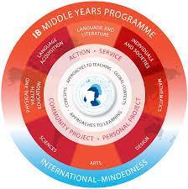

In 2015-16, West High School began implementing the International Baccalaureate (IB) Middle Years Programme (MYP). West High School is an authorized IB MYP World School. IB World Schools share a common philosophy – a commitment to improve the teaching and learning of a diverse and inclusive community of students by delivering challenging, high quality programmes of international education that share a powerful vision.

The MYP is designed for students in grades 6-10. West High School is in a partnership with Bearden Middle School to offer the MYP to **all** students, grades 6-10. It provides a framework of learning that encourages students to become creative, critical and reflective thinkers. The MYP emphasizes intellectual challenge, encouraging students to make connections between their studies and the real world. It fosters the development of skills for communication, intercultural understanding and global engagement – essential qualities for young people who are becoming global citizens and global leaders.

All students at West High School in grades 9 and 10 will be MYP students. At the end of their 10th grade year, students will have the choice to continue into the IB Diploma Programme (DP) or follow a traditional high school curriculum track. Students may choose to pursue the Full IB Diploma, take individual IB classes, take Advanced Placement (AP) classes or college prep (CP) level classes. Each student will discuss and design their individual pathway with their counselor during their 10th grade year.

**865 ACADEMIES**

During the Fall of 2024, West will launch the 865 Academies initiative. The 865 Academies initiative is aimed at transforming the high school experience for Knox County students, and Freshman Academy is the first step on that journey. Freshman Academy is designed to welcome 9th-graders to high school, provide a smaller learning community to build connections with teachers and classmates, and prepare students to select an academy pathway for Grades 10-12.

This happens in several ways:

Freshman Seminar is a class that focuses on helping students identify interests, aptitudes and professional skills, through tools including the YouScience assessment tool; Career Exploration activities introduce students to professional opportunities and host guest speakers from various industries; Industry Experience visits will provide insight into potential career paths related to their interests. The transition from middle school to high school is essential for academic success, and Freshman Academy will prepare students to take advantage of all 865 Academies have to offer! All freshman students will be enrolled in the Freshman Seminar course.

During the spring of their freshman year, students will select a career pathway to follow during their tenure at West High. The academies are listed below:



Guaranteed experiences are an integral part of 865 Academies. They are listed below for each grade level.

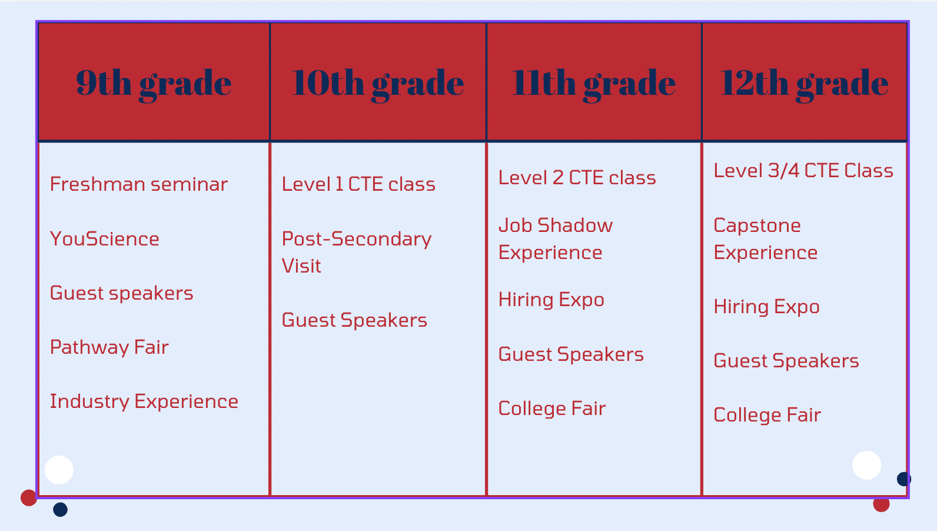

You can access the frequently asked questions about the 865 Academies [here](https://www.knoxschools.org/Page/24584).

**ATHLETICS**

West is proud of its athletics program. Although academics are of primary importance, an excellent athletic program in itself can be a very meaningful learning experience. As a member of the Tennessee Secondary School Athletic Association (TSSAA), West offers the following TSSAA sanctioned-sports: baseball, basketball, cheerleading, cross country, football, golf, soccer, softball, tennis, track and field, volleyball and wrestling.

**Note:** Students who are interested in participating in college sports should start the certification process early, usually by the end of the junior year. Information concerning the certification process is available in Student Services.

We believe that athletics enhance an athlete’s opportunity to learn, to encourage physical, mental & social awareness and to help create with him/her a greater desire to improve one's self. Our goal in athletics is to help the student athlete reach his/her potential academically, as well as athletically, and to become a more productive member of society after having participated in our athletic program.

**Objectives**

* To develop self-confidence and a positive self-concept.
* To set and work toward accomplishment of goals.
* To grow socially, emotionally and physically in a nurturing environment.
* To learn teamwork and cooperation.
* To develop a desire to excel.
* To learn to treat others as we would have others treat us.
* To receive self-satisfaction of accomplishment and enjoyment of participation.
* To develop an awareness and respect for a high degree of physical fitness through exercise and good health habits.

**Eligibility**

1. A student athlete must have earned at least 6 term credits the preceding school year.
2. A student athlete must not be nineteen years of age on or before August 1st.
3. A student athlete is permitted eight terms of eligibility beginning with the ninth grade.
4. A student athlete must be taking at least three subjects per term.
5. A student athlete must have an annual medical examination before he/she participates in a practice or game.
6. A student athlete must have his/her parent/guardian complete the parent consent form (athletic participation and/or weight training).
7. A student athlete must comply with all eligibility rules as set forth by TSSAA.

**Athletic Insurance**

Insurance coverage for West High School is a secondary coverage that covers only after parents have filed on their primary insurance plan. The cost for a catastrophic plan for a very serious injury is assessed to each participating student athlete. This insurance is not optional and must be paid ($60) prior to participation as per Knox County Policy I-171. (*“Every participant in athletics shall participate in the Knox County Schools Athletic Insurance Program.”*)

**Privilege - Not a Right**

The athletic department encourages participation in athletics as an extracurricular activity, and such participation is a privilege. No one is guaranteed a place on a team. Without such a guarantee, the student must be ready to meet the standards established by the school/team or have the possibility of being dismissed as a member of that team. The better one's talent, the better one's chance is of making the team. Rarely, however, will talent be the sole criteria. Other factors such as attitude, desire, cooperation and self-discipline will play important parts in determining placement on the team.

**Suspensions & Fines**

Students are expected to demonstrate professionalism and appropriate behavior both on and off the field of play. Any West High student-athlete that is ejected from a contest will be required to miss one full week of their sports schedule for the first offense and two full weeks for the second offense. Please note that any athlete ejected from a contest will not be allowed to be on the sidelines, bench, or locker room areas during games until the suspension has been served. The player may watch the game from the stands. Students who are ejected as fans, will be required to pay a $250 fine per TSSAA requirements in order to participate in any further events.

**SCHOOL SAFETY REGULATIONS**

1. Every student, whether they attend a dual enrollment class or not, must check in at the Front Office upon arrival to school. Dual Enrollment students are advised to park as close to the Front Office as they can.
2. Students are not allowed to open exterior doors to the building except under direct supervision (watching them) of a teacher. This includes opening doors for late arrivals to campus. Students in violation of this will be subject to disciplinary action.
3. Students returning from the athletic fields to the main building must use the rear cafeteria doors, under the supervision of a coach or teacher.
4. Students are not allowed to “force open” exterior doors. Cameras are on all exterior doors. Students using a “force open” method will be subject to disciplinary measures, including suspension from school, forced damage payment, and a report to law enforcement.
5. Students are not allowed to climb over security locks (such as gates between main building and vocational) in order to bypass security features.
6. Students violating traffic regulations in the parking lot (speeding, reckless driving) will be subject to disciplinary action and will lose parking privileges, without a refund of the parking fee.
7. Students should participate fully in all school safety drills.
8. Students should report any non-staff adult who does not have a badge or visitor ID to a teacher immediately.

**HALLWAYS**

1. Once the tardy bell has sounded, students are not to be in the hallways until ten minutes after the start of class. Students are not to be released during the ten minutes prior to the bell for the next class. If a student needs to be in another class, the student should either arrange the prior day (among all teachers involved) for the student to report directly to the class, or the student should wait fifteen minutes for release.
2. Students should always have a hall pass from the teacher when in the hallway during authorized release times. Hall passes are not to be issued during unauthorized (10 after the bell, 10 prior to the next) times.
3. Students are not allowed to congregate at the intersection of the main hallway and elevator hallway (outside Room 100) just above the steps. This is a main thoroughfare and sees the most traffic flow during class changes.

**DRILLS and EMERGENCY PROCEDURES**

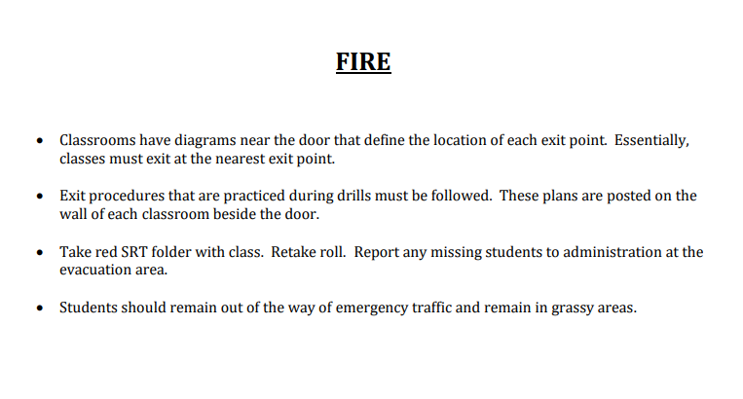

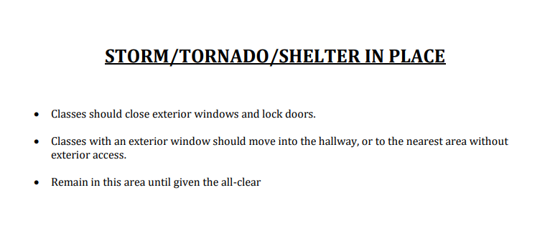

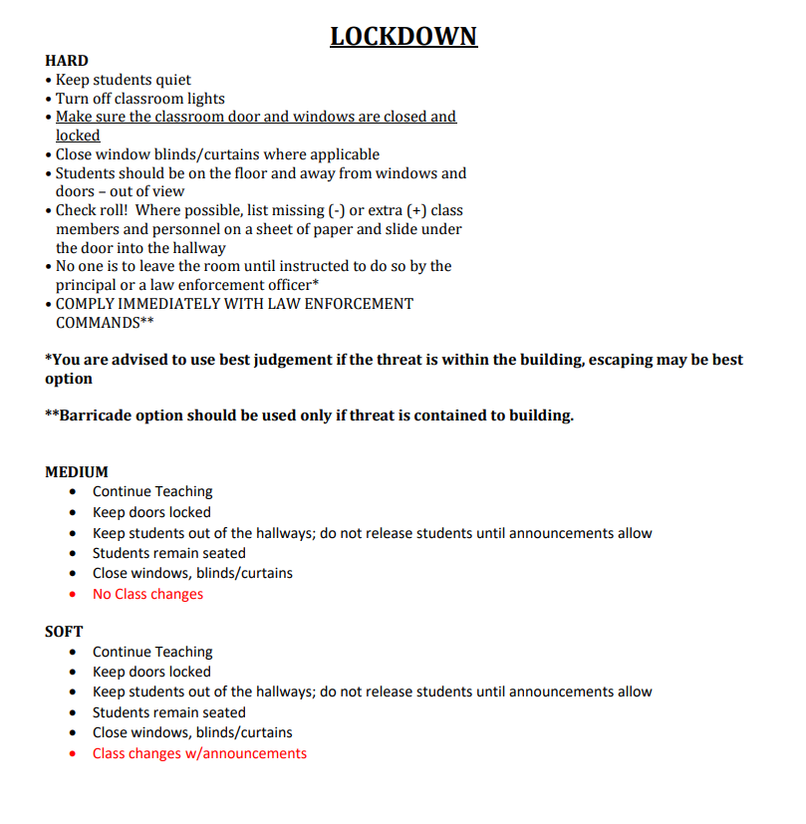

**Regular Schedule One Hour Delay**

| **1st Block** | **9:30-10:43** |
| --- | --- |
| **3rd Block** | **10:50-12:50** |
| **1st lunch** | **10:43-11:11** |
| **2nd lunch** | **11:16-11:44** |
| **3rd lunch** | **11:49-12:17** |
| **4th lunch** | **12:22-12:50** |
| **2nd Block** | **12:57-2:10** |
| **4th Block** | **2:17-3:30** |

| **1st Block** | **8:30-9:50** |
| --- | --- |
| **Advisory** | **9:56-10:41** |
| **2nd Block** | **10:47-12:07** |
| **3rd Block** | **12:13-2:02** |
| **1st lunch** | **12:07-12:32** |
| **2nd lunch** | **12:37-1:02** |
| **3rd lunch** | **1:07-1:32** |
| **4th lunch** | **1:37-2:02** |
| **4th Block** | **2:08-3:30** |

**Two Hour Delay**

| **1st Block** | **10:30-11:23** |
| --- | --- |
| **3rd Block** | **11:30-1:30** |
| **1st lunch** | **11:23-11:51** |
| **2nd lunch** | **11:56-12:24** |
| **3rd lunch** | **12:29-12:57** |
| **4th lunch** | **1:02-1:30** |
| **2nd Block** | **1:37-2:30** |
| **4th Block** | **2:37-3:30** |
|  |  |

**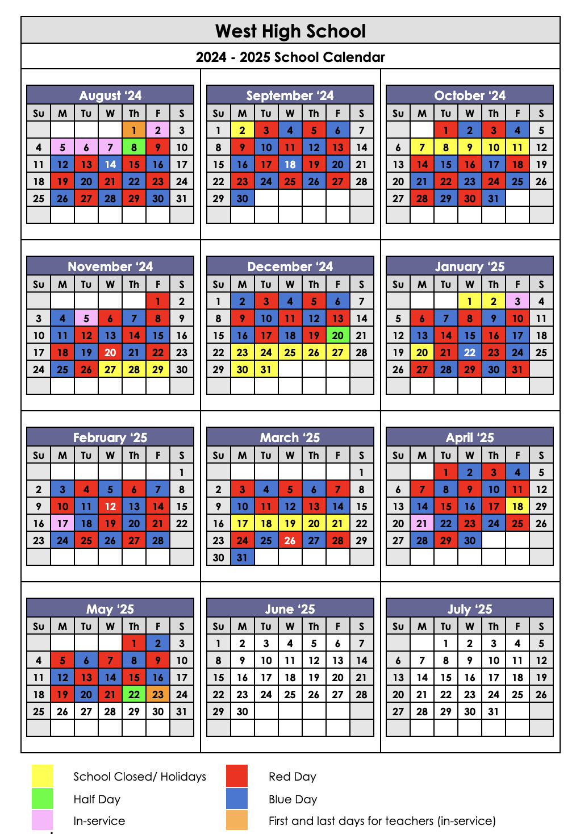****RED/BLUE CALENDAR**